

***Capstone Project***

**Report 1: Introduction**

*Personal Finance Management*

**Author: PFM Team**

**Supervisor: Mr. Nguyen Van Hien**

**Hanoi, 13th Sep, 2012**

**Record of changes:**

|  |  |  |  |  |
| --- | --- | --- | --- | --- |
| **Date** | **Change Item** | **Description** | **By** | **Version** |
| 13/09/2012 | All | Create the document | GamNT01326 | 1.0 |
| 20/09/2012 | Overview of existing systems | Update | GamNT01326 | 1.1 |
|  |  |  |  |  |

Table of Contents

**A.** **Overview** 4

**I.** **Project overview** 4

**1.** **Project information** 4

**2.** **Group information** 4

**II.** **Initial idea** 5

**III.** **Overview of existing systems** 6

**1.** **Application in Vietnam** 6

**2.** **Foreign applications** 8

**IV.** **Expected system** 12

**B.** **Reference** 13

1. **Overview**
2. **Project overview**
3. **Project information**

* Project name: **Personal Finance Management**
* Project code: **PFM**
* Project type**: Mobile application**
* Duration: **Sep 2012 to Dec 2012**

1. **Group information**

Supervisor:

Name: **Mr. Nguyen Van Hien**

E-mail: [**hiennv@fpt.edu.vn**](mailto:hiennv@fpt.edu.vn)

Phone: **0977.999.707**

Role: **Lecture**

Team members:

|  |  |  |  |  |  |
| --- | --- | --- | --- | --- | --- |
| No | **Full name** | **Student code** | **Phone** | **E-mail** | **Role** |
| 01 | Nguyen Anh Tuan | 01030 | 01229249209 | TuanNA01030@fpt.edu.vn | Leader |
| 02 | Lai Le Le Linh | 01355 | 01689908772 | LinhLLL01355@fpt.edu.vn | Member |
| 03 | Le Thi Minh Khanh | 01262 | 01665291990 | KhanhLTM01262@fpt.edu.vn | Member |
| 04 | Nguyen Thi Gam | 01326 | 01685201603 | GamNT01326@fpt.edu.vn | Member |
| 05 | Nguyen Duc Loc | 01006 | 01234351990 | LocND01006@fpt.edu.vn | Member |

1. **Initial idea**

The idea of our product comes from actual problems, that how to help people manage their personal finance in the way of the most quickly and usefully. Normally, you have to save your receipts, record all your purchases, add up your expenses, and calculate how much you have left to spend or save. Maybe that final result sends you into unimaginable even complete shock, and you wonder why your money goes so quickly. You must spend lots of time for recalling accounts payable, expense and income. Sometime, you forgot and you cannot remember all of them.

And now we’d like to introduce our product which will bring to you a place to easily manage your finance, without waste of time to remember and don't afraid forget any account. It will do all of work for you: automatically calculating your expenses and purchases; analyzing your spending with reports and pie charts; alerting you of upcoming bills; planning your future spending; and more.

Not only manages finance, our system but also helps storage data by synchronization data. With this when you change or lost mobile, all your data will not be lost and you can use this function to get back data and continue use application but don’t need input again.

With the rapidly expansion of mobile with android OS, we hope that our product will become most popular application, to help more people managing personal finance.

1. **Overview of existing systems**

There are some existing system and our analysis about them.

1. **Application in Vietnam**
   1. **Money Lover**

* **Features:**

This application was developed by a Vietnamese. Money Lover is a financial budget management app that can be used for simple tasks such as tracking income and expenses on up to smarter advanced tools such as debt management and budget reports. The application supports more than 30 languages.  
After successful installation, the main interface of the program, including six function buttons will appear.

* Add Transaction: button will help you record the transaction revenues, expenditures, loans, investment...
* Cash Book: is a list of income and expenditures
* Debt Management: helps you manage the lending and borrowing easier.
* Statistics: give you charts and compare the income and expenditures.
* Budget plan: where to plan, estimate your expenses.
* Tools, gives you four basic tools: Currency Exchange, Bank Finder, ATM Finder and Interest Rate.

The app supports multiple profiles (in Premium), for example, you can set up one profile for personal and one for your office. It also can protect your data when you go to the settings to enable “Pattern Lock”. More importantly, have a look at the Auto Backup feature. From there you can set up scheduled backups of your financial data.

When you have an income or expenditure, you add them to "Cash Book" by selecting "Add transaction" and choose types (income, expense, Receivable or Payable). Then input name, select a category ... Finally, choose "Save" button, your income and expenditures are recorded and managed very easily. To view, you touch "Cash Book".

* **Advantages**
* Loaded with features both simple and comprehensive for personal financial management!
* Support for pattern lock to open app and automatic schedule of data backup!
* Produce charts and stats from data.
* Supports multiple profiles (in Premium version).
* Support many functions and languages
* **Disadvantages**
* Does not have a synchronize solution.
* Have too many unnecessary functions such as “Currency exchange”, “Tip calculator”, “ATM finder”, “Bank finder”.
* Have to buy the full version of the application to use some functions like “Account manager”…
* Some functions have not completed yet and need to be updated in the next version. It is also uncomfortable to bring user to home screen, because user must go back to many screens.

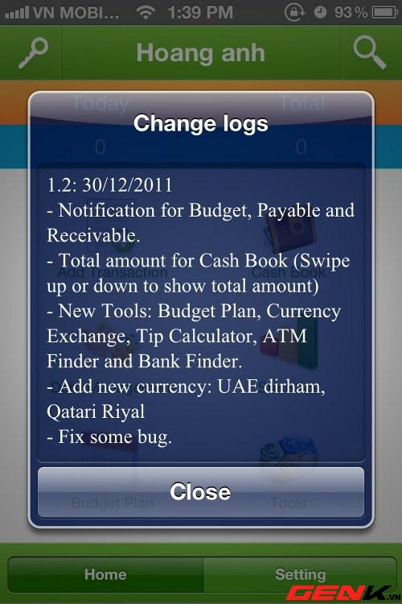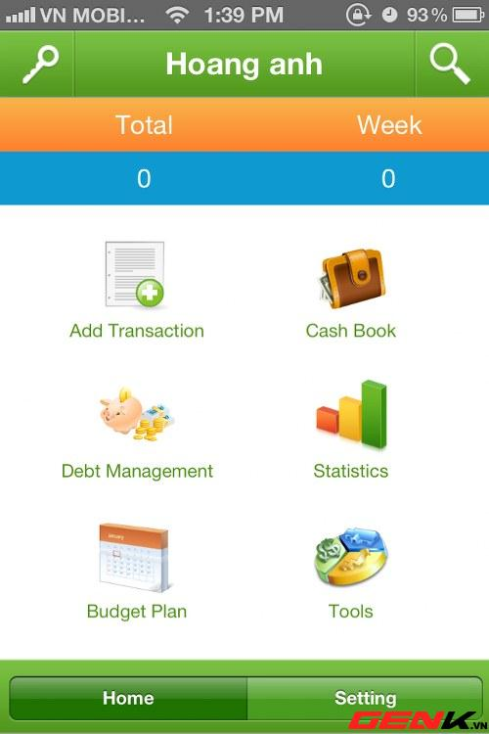

*Figure 1: Money Lover Interface*

1. **Foreign applications**
   1. **CWMoney**

* **Features**

This application helps user to keep track of all their expenses and incomes in an easy way.

First of all, you need to select your language and then restart the application in order to make it work properly. Then, you can start use apps by adding some expenses or incomes.

The man interface of program including four functions:

* Expense: you can make a recording, set a default picture, and include a category and subcategory (Food and Breakfast for instance), the type of the account used (Cash, Credit Card…) and even the project (Holiday, Wedding, Travel…). You can also take notes about any particular thing you want to add.
* Income: same Expense function
* Data Manager: keep track of the money spent in a great variety of ways. A report is also provided (in a Pie or a Bar Chart) to help you visualize everything better.

Bottom of the screen shows total expense, income follow daily, weekly and monthly.

* **Advantages**
* The system is simple and easy to understand for users.
* Support UI Theme.
* Support multiple accounts and currency.
* Support GPS, Camera, Album, Voice.
* Data Export (Excel XML, CSV).
* Backup Send to Dropbox, Gmail, FTP...
* **Disadvantages**
* Have less function, lack schedule function, borrowing and lending function.
* Must purchase to synchronize data.
* Have some items are unnecessary for users.

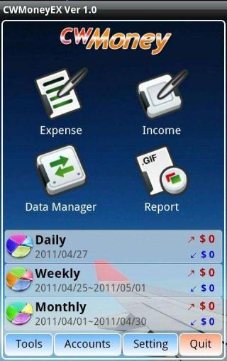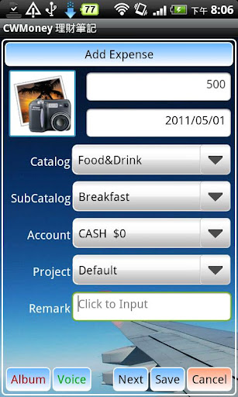

*Figure 2: CWMoney Interface*

* 1. **Easy Money**
* **Features**

This application helps you track your expenses and stick to your budget quickly and easily using a simple yet powerful user interface.

The man interface of program including three accounts default (Cash, Credit Card and Bank Account) and three buttons:

* New Account: User can create new account with Account Name, Currency, Description, Starting Balance…
* View Budget: User can view all accounts that they created. In each account user can Add Transaction (Income or expense). In this function user can create new Budget. User also can use Bills Reminder in this function.
* Bills Reminder: Add new Reminder and Receive notifications of upcoming and overdue bills - for both one-time payments as well as recurring bills.

Interactive Reports & Graphs let you analyses income, expenses, cash flow and balance over various customizable date ranges.

Set monthly budgets on specific accounts and/or categories and monitor them via color-coded budget health bars charts

* **Advantages**
* Track income and expenses for multiple accounts in multiple currencies
* Support transfers between accounts
* Lock application using a 4-digit security passcode
* Backup data onto SD card
* Import & Export transaction data to .CSV & .QIF files
* **Disadvantages**
* Don’t have borrowing and lending function.
* To use this application, you must buy it.

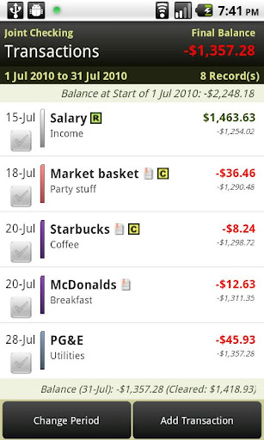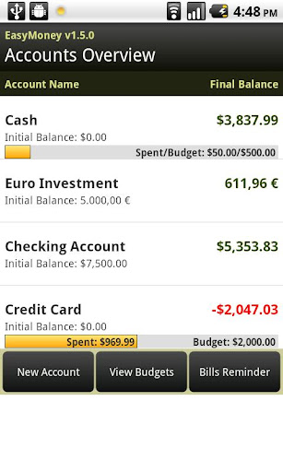

*Figure 3: Easy Money Interface*

1. **Expected system**

From above statistic about existing system, we have a table of comparison as follows:

|  |  |  |  |  |
| --- | --- | --- | --- | --- |
| **Application Name** | **Money Lover** | **CWMoney** | **Easy Money** | **\*Money Tracker** |
| **Expense/Income** | Yes | Yes | Yes | Yes |
| **Schedule** | Yes | No | Yes | Yes |
| **Borrowing/Lending** | Yes | No | No | Yes |
| **Report/Chart** | Yes | Yes | Yes | Yes |
| **Warning** | Yes | Yes | Yes | Yes |
| **Synchronize Data** | No | Yes | Yes | Yes |
| **Input by NFC** | No | No | No | Yes |
| **Input by Q code** | No | No | No | Yes |
| **Score** | 5/8 | 4/8 | 5/8 | 8/8 |

Table 1: Comparative Matrix between the Existing System and the Money Tracker

Not only try to solve their some disadvantages, but also we will also learn from their good points. We expect that our system will bring to user all benefits and can be different with others.

There are some main features of our product:

* **Interface**: Our system will bring to user most friendly interface, easy to understand for user.
* **Function**: Our system also provides all function necessary to manage finance such as input expense, income, schedule, report, chart, warning and synchronize data. Furthermore, our system also helps user to input data faster by using NFC.
* Schedule: User can plan schedule follow week or month. In this function, user can input monthly budget or input total money for each category. System will compare expense/income with schedule, if it over budget, system will show warning message for user.
* Borrowing and lending: In this function, user can input interest to calculator the debts and loans.
* Expense and Income Management: helps user manage revenue and expenditure every month. In this function, user can input data faster by using NFC and Q code.
* Warning: reminder user when expenditures exceed plan or the maturity of borrowing or lending
* Report: helps user has an overview of the expenses in a month, compare with plan or other month.
* Synchronize: help storage data, when user change or lost mobile, all their data will not be lost and user can use this function to get back data and continue use application but don’t need input again.

1. **Reference**
2. <http://www.pcmag.com/article2/0,2817,2343674,00.asp>
3. <http://financialsoft.about.com/od/pdasoftware/tp/Manage_Money_Mobile_Device.htm>
4. <http://genk.vn/c186n20120116111748198/money-lover-tren-ios-ung-dung-quan-ly-tien-cua-nguoi-viet.chn>
5. <https://play.google.com/store/apps/details?id=com.lib.cwmoney&feature=related_apps#?t=W251bGwsMSwxLDEwOSwiY29tLmxpYi5jd21vbmV5Il0>
6. <http://www.androidtapp.com/money-lover/>
7. <http://www.baomoi.com/Money-Lover--Phan-mem-Android-Viet-tro-lai-voi-nhieu-tinh-nang-moi/76/6982525.epi>
8. <http://www.androidzoom.com/android_applications/finance/cwmoney-expense-track_basrc.html>
9. <http://www.handy-apps.com/main/EasyMoney.aspx>